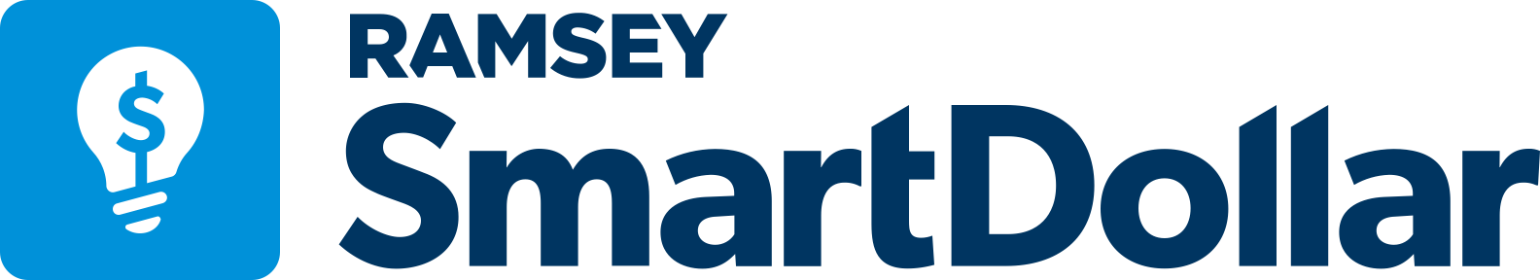
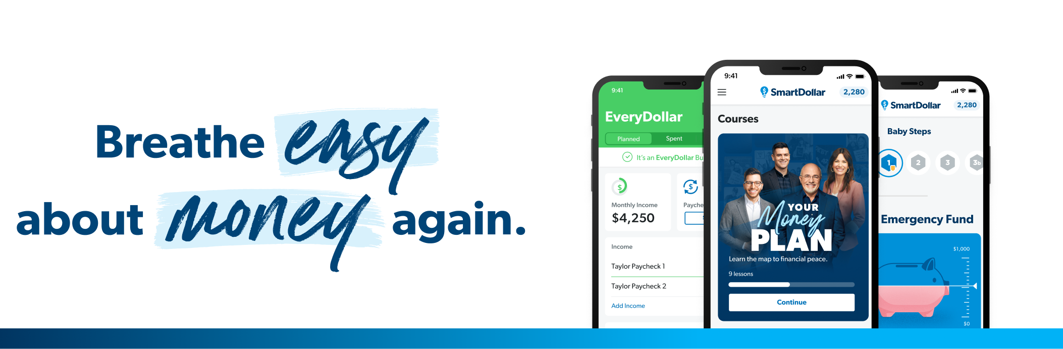
Say hello to SmartDollar, your free financial wellness benefit! Ditch money stress and learn to spend less, save more, and get rid of debt—for good.
You’ll learn how to:  - Handle financial emergencies  - Eliminate debt  - Change spending habits  - Tackle money anxiety | Stay on track with access to:  - EveryDollar, a budgeting app  - The Debt Snowball Tool  - Financial coaching  - Educational content
YOU have the power to change your life. Take control of your money today!
Enter this keyword to create your free account: [your company keyword]
 | 