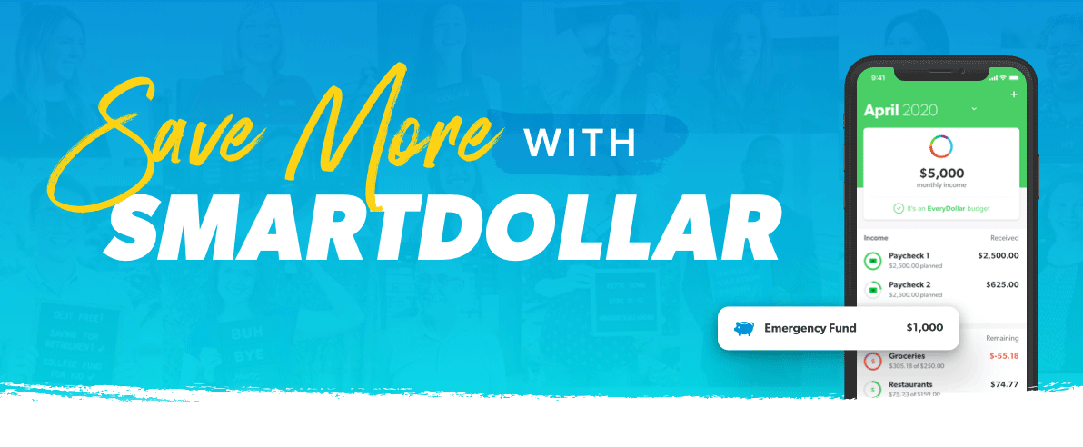
Do you ever find yourself wondering where the money from your last paycheck went?

SmartDollar can help. Instead of wondering where your money went, tell it where to go with our interactive tools—including EveryDollar, our budgeting app. Imagine the peace that comes with having a fully funded emergency fund—to know that your expenses are already covered for the next three to six months? You’d be surprised what you could accomplish with intensity and focus.
Stop worrying about your everyday expenses and jump-start your savings with tips and motivation from our team of experts, including bestselling authors and financial experts Dave Ramsey, Chris Hogan and Rachel Cruze.
SmartDollar is a free and confidential financial wellness program designed to help you adjust your habits to get on track and save for the things that really matter to you. Get started today and learn about the step-by-step plan that is helping millions reach their money goals.

