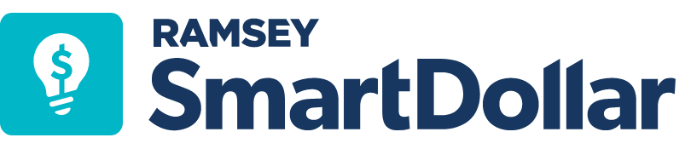
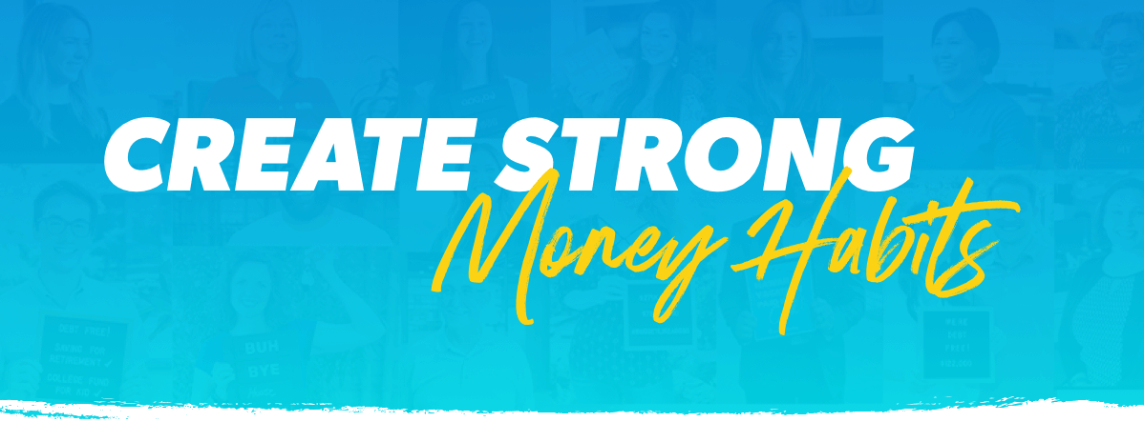
Good money habits take a while to form, but just like working out, the transformation can be incredible!

When was the last time you thought about your financial well-being? Smart money habits take effort at first—but the literal payoff is worth it!
We care about your overall well-being, which is why we are pleased to be partnering with SmartDollar, an online financial wellness program from Ramsey Solutions. It is available at no cost to you, and all your data will remain confidential and secure.

We want to see you thrive and accomplish your money goals, and the foundation for that success starts with building smart money habits.
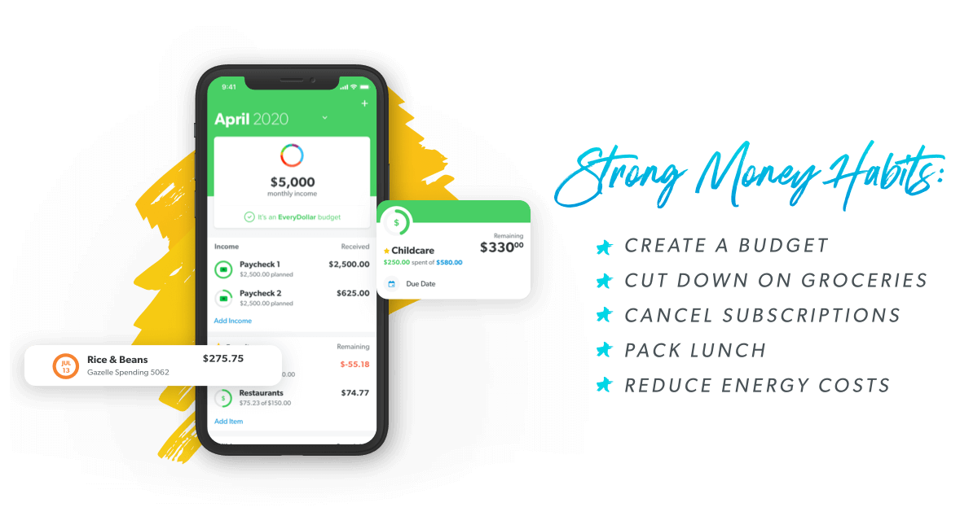
SmartDollar will provide you with the tools and education to help you take control of your money once and for all. We’re offering the program to you and your family for free, so get started today!

