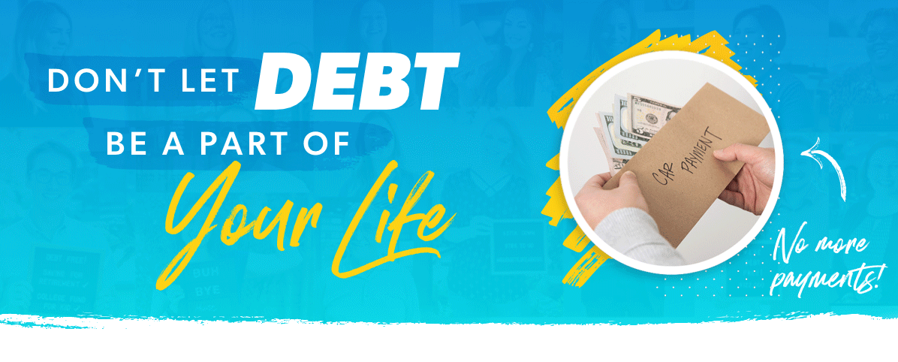
Fact: 4 out of 10 Americans spend nearly 50% of their take-home pay on debt like credit cards, car loans, and student loans.

Let’s put this into perspective. For some people, paying off all debts would be like getting a 50% raise! It is possible to make real financial progress this year, and SmartDollar has all the resources to help you make it happen.

Through video lessons and interactive tools, you’ll learn how to conquer your money goals once and for all. SmartDollar is free and confidential, and you could be debt-free in record time by working the plan! Just think about the opportunities that you could say yes to with 50% more money. The average person using SmartDollar pays off $10,000 in debt and saves over $6,200 in the first year. Don’t wait another minute!

