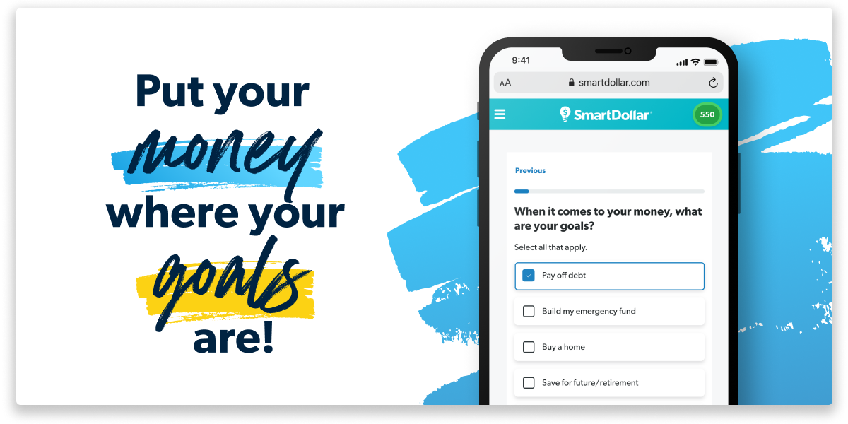
Stop stressing over your finances and take action with your
FREE SmartDollar account provided by <company name>.

Be proactive about your paycheck.

Managing your money shouldn’t start on payday. Set your money goals ahead of time and be proactive with a plan for the cash you work so hard to earn! Ditch debt. Stash cash for emergencies. Gain confidence for your future!

Create your free SmartDollar account in at
smartdollar.com/enroll/companyname.



SmartDollar’s motivating content inspires behavior change for real, life-long results—you just need to make the choice to start now. You won’t just learn what to do with your money, you’ll learn why. WHY you should have retirement goals. WHY a monthly budget isn’t restrictive. WHY paying off debt quickly will allow you to build MORE wealth!
Sign up for SmartDollar and take the first step toward achieving your financial goals!

