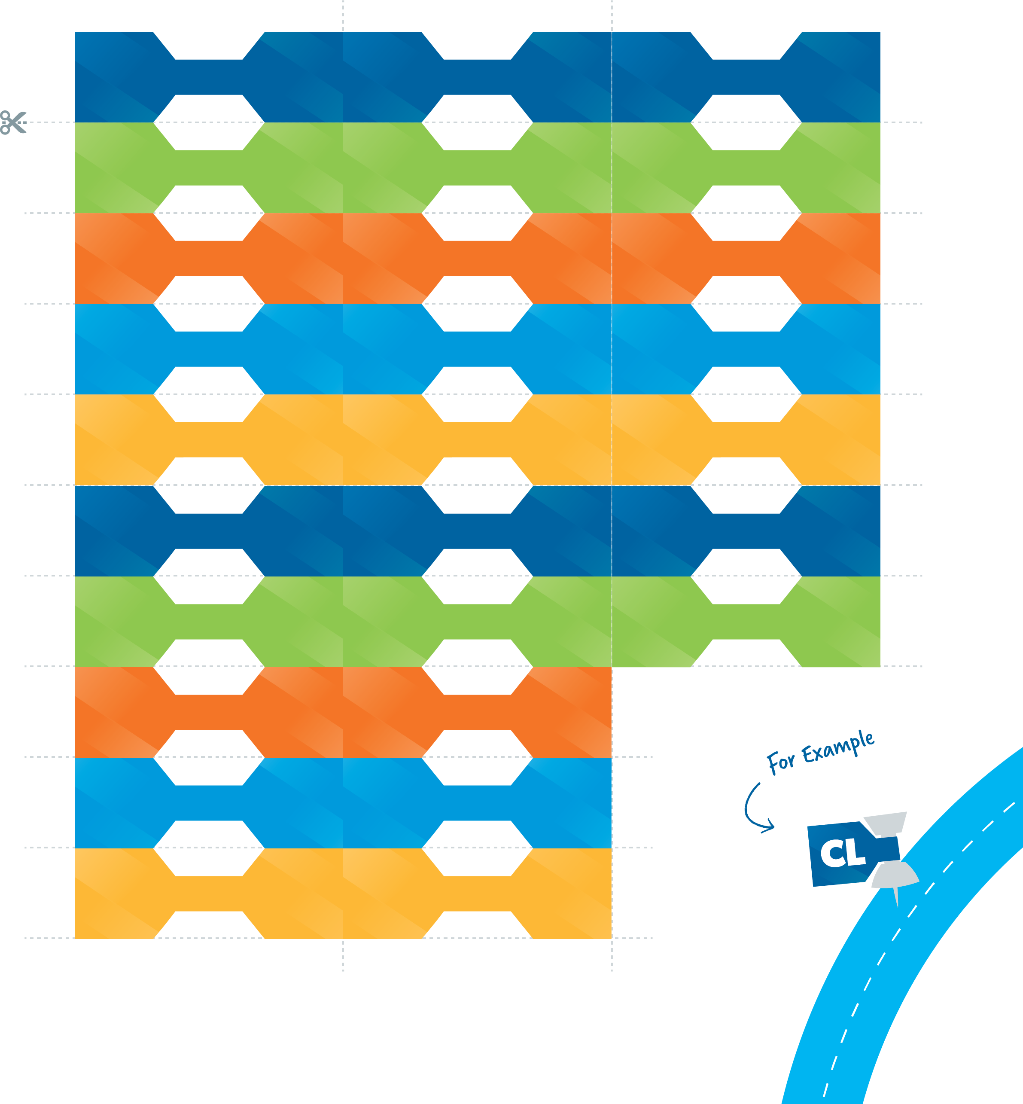INSTRUCTIONS

Type in each student’s initials, print, and cut out the following tabs. Then fold around a push pin to easily track students’ progress.

|  |  |  |  |  |  |
| --- | --- | --- | --- | --- | --- |
|  |  |  |  |  |  |
|  |  |  |  |  |  |
|  |  |  |  |  |  |
|  |  |  |  |  |  |
|  |  |  |  |  |  |
|  |  |  |  |  |  |
|  |  |  |  |  |  |
|  |  |  |  |  |  |
|  |  |  |  |  |  |
|  |  |  |  |  |  |